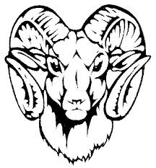
Riverside Ram’s Arrival Schedule 2019-2020:
The earliest students may arrive on campus is 7:30 AM.
Morning Carpool: ECSE, 1st, 2nd and 3rd grade drop-off in the front of the school;
ECE, K, 4th and 5th drop-off in the back circle area

7:30 AM-7:45 AM: Students will go to the gym (3rd,4th, 5th) or cafeteria (ECE, K, 1st, 2nd).

Students eating breakfast may go to the cafeteria and then their designated area if
applicable.

Breakfast: 7:30 AM to 7:50 AM
Bell Rings to go to class: 7:45 AM
Tardy Bell rings and students in seats: 7:55 AM
If you arrive after the tardy bell rings, please sign-in your student in the front office.
Riverside Ram’s Dismissal Schedule 2019-2020:
ECSE/ECE: 2:45 PM (ECSE parents must arrive by 2:45) (ECE teachers will put students in the
car/walk them to you)

Kindergarten: 3:00 PM (K teachers will put students in the car/walk them to you)
Bus Riders: 3:10 PM
Walkers and Car Riders: 3:15 PM (Walkers are escorted across the crosswalk at 3:15 PM)
Parent waiting area is located on the grassy areas to the right of the crosswalk and by the
flagpole.

All students must be picked-up by 3:30 PM.

Thank you for your continued support!

Updated 8/16/18
